**Actividad 5. Teoría de conjuntos**

Juan Esteban Alfonso Hernandez

T.I 1032940696

Ficha:2926378

Sena

Matemáticas

Diana Torres

12 de nov. de 24

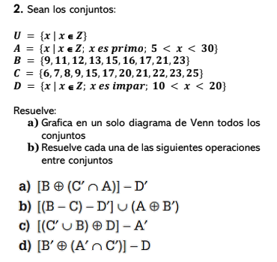

R:/

a)

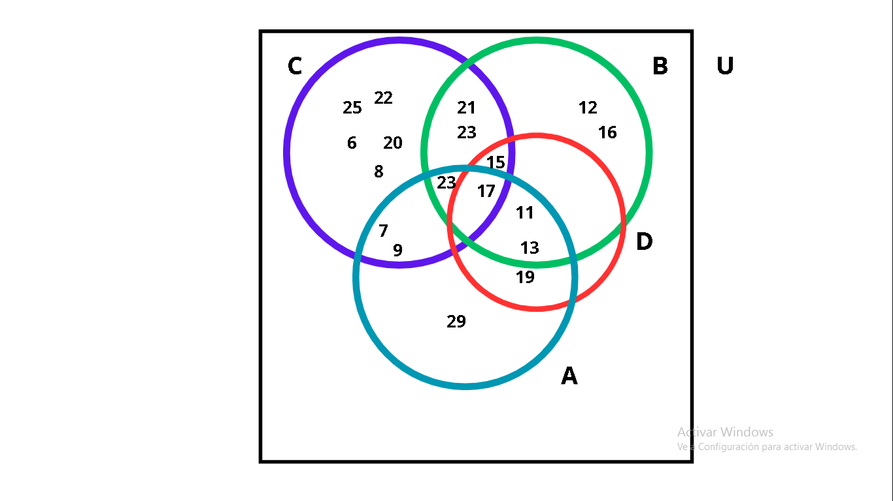

b)

A = {7, 11, 13, 17, 19, 23, 29}

B= {9, 11, 12, 13, 15, 16, 17, 21, 23}

C= {6, 7, 8, 9, 15, 17, 20, 21, 22, 23, 25}

D= {11, 13, 15, 17, 19}

1. **[B⊕(C´ ∩ A)] - D´=**

D´= {6,7,8,9,12,16,17,20,21,22,23,25}

C´ = {11,12,13,16,19,29}

(C´ ∩ A) = {11,13,19,29}

[B⊕ (C´ ∩ A)] = {9,12,15,16,17,21,23,29}

[B⊕ (C´ ∩ A)] - D´= {9,15,29}

**B) [ (B - C) - D´] ∪ (A ⊕ B´)**

(B-C) = {11,12,13,16}

D´= {6, 7, 8, 9,12,16,20, 21, 22, 23, 25, 29}

[(B-C)-D´] = {11,13}

B´ = {6,7,8,19,20,22,25,29}

(A ⊕ B´) = {6,8,11,13,17,20,22,23,25}

[(B-C)-D´] ∪ (A ⊕ B´) = {6,8,11,13,17,20,22,23,25}

**C) [(C´ ∪ B) ⊕ D] – A´**

C´ = {11,12,13,16,19,29}

(C´ ∪ B) = {9, 11, 12, 13, 15, 16, 17,19, 21, 23,29}

[(C´ ∪ B) ⊕ D] = {9,12,13,15,17,19}

A´ = {8, 9,12,15,16 ,20, 21, 22,25}

[(C´ ∪ B) ⊕ D] - A´ = {13,17,19}

**D) [B´ ⊕ (A´ ∩ C´)] – D**

A´ = {6,8,9,12,15,16,20,21,22,25}

C´= {11, 12, 13,16,19,29}

(A´ ∩ C´) = {12,16}

B´ = {6, 7, 8,19,20,22,25,29}

[B´ ⊕ (A´ ∩ C´)] = {6, 7, 8,12,16,19,20,22,25,29}

D= {11, 13, 15, 17, 19}

[B´ ⊕ (A´ ∩ C´)] – D = {6, 7, 8,12,16,20,22,25,29}